Counseling Connection
Connect with your counselors!
Mr. Ford: mford@bathcsd.org or x1044
Mrs. Rice: drice@bathcsd.org or x1045
Phone 607-776-3301 and our extension

DLL Middle School
“Every Student Every Day”

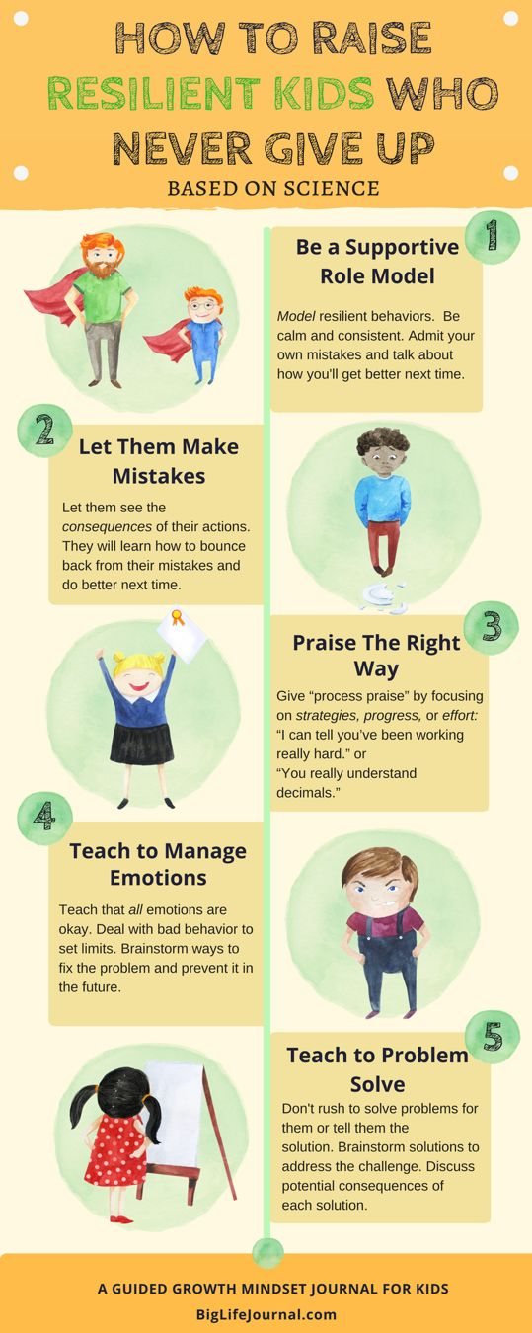
From the Middle School Counseling Office

Week of May 11th, 2020
This week’s Counseling Connection is focusing on “Resiliency”. What does it mean to be resilient?
Resilience is a person’s ability to cope with changes and challenges and to bounce back during difficult times.
While it does seem true that some kids seem to be naturally more resilient than others, we can teach and model certain behaviors that increase “grit” or resiliency in our kids so they can not only cope during the difficult times but bounce back after the difficult times have passed.
Resiliency Skills
When thinking about promoting resiliency in our kids, one of the best ways to encourage it is to live it, or model it ourselves. This is a more “show me” or “do as I do” approach.
The info-graph on the right has some great tips on promoting resiliency skills.
Have a great week and don’t hesitate to contact your counselors if you need to!!

