Counseling Connection
Connect with your counselors!
Mr. Ford: mford@bathcsd.org or x1044
Mrs. Rice: drice@bathcsd.org or x1045
Phone 607-776-3301 and our extension

DLL Middle School
“Every Student Every Day”

From the Middle School Counseling Office

Week of April 27th, 2020
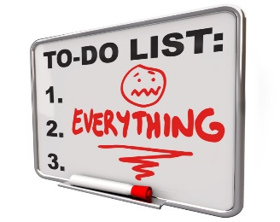
We hope this weekly newsletter from your DLL Middle School Counselors, Mr. Ford & Mrs. Rice finds you all healthy and happy amidst these unprecedented times in our lives. We are hopeful these weekly newsletters might provide families with some tips and ideas regarding topics such as social skills, communication, emotional regulation, coping skills and other things. We realize every family is different and even though we are all going through this same ordeal we may all be experiencing it very differently. We hope some of the things we provide in our newsletter will be beneficial to our busy families.
Coping Skills
What are coping skills? This is a term that we hear a lot but what does it mean, exactly? A coping skill is a way that we choose to respond to our feelings and emotions, such as fear, anxiety, stress, worry, and anger. There are positive/healthy coping skills and of course there are negative/unhealthy types of coping skills as well.
We want to foster and encourage positive coping skills in ourselves and our kids during times of emotional distress. Negative coping skills may help us to feel better in the moment but often lead to even more negative outcomes down the road.

So what are these Positive Coping Skills? It isn’t as scary as it sounds! Lots of things we do every day are actually Coping Skills, we just might not realize it!
Here are some examples:
- Using positive self-talk
- Drawing or painting
- Reading a book
- Listening to music
- Talking with friends or a trusted adult
- Being in nature or going for a walk
- Exercising or practicing Deep Breathing
- Playing sports or a game
- Resolving the problem
- Sharing your feelings
