Counseling Connection
Connect with your counselors!
Mr. Ford: mford@bathcsd.org or x1044
Mrs. Rice: drice@bathcsd.org or x1045
Phone 607-776-3301 and our extension

DLL Middle School
“Every Student Every Day”

From the Middle School Counseling Office

Week of May 4th, 2020
This week’s Counseling Connection is focusing on “Self Regulation” or “Emotional Regulation”. We have heard these terms for several years, but what do they mean exactly for our kids?
Simply put, Emotional Regulation is the ability to control your emotions, thinking, behavior and actions in different situations. It is the ability to tolerate situations and distress and form appropriate responses.
Self/Emotional Regulation skills are something that naturally mature over time just like other developmental processes; as children get older they learn to think before they act. However, lots of kids need a little more support in developing these important skills!
Emotional Regulation Skills
How to help a child develop self regulation (or emotional regulation):
Talk about what emotions and feelings mean for them – have them describe what it feels like to be angry, frustrated, sad, lonely, worried, happy, confused, scared, joyful, anxious, etc. This will help them understand their own feelings and be able to identify what feeling they are experiencing in the moment.
Then come up with a “menu of options” with your child of things he/she thinks would work when experiencing that emotion or feeling. If your child has input in coming up with the options the more likely he/she will be to use them!
A visual reminder works great for this and there are lots of fun and creative ways to make them! (P.S. they work great for us adults too!) A simple example is:
When I feel: _____ _____ _____ _____
I can: _____ _____ _____ _____
Kids would pick feelings words such as: worried, angry, frustrated, sad
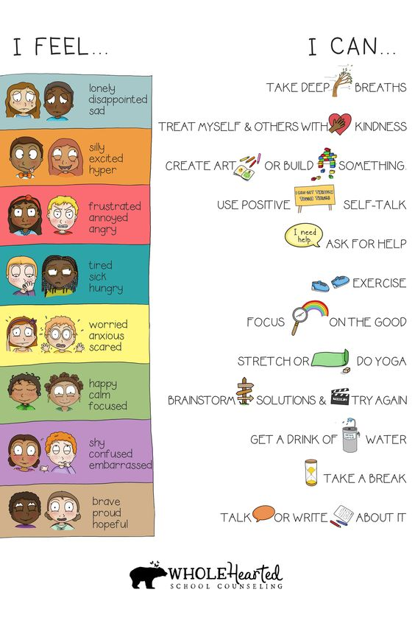
Then from their menu of options they would pick a strategy they thing would help such as: talk to my parent, practice my Balloon Breathing, move my body, watch a funny video

